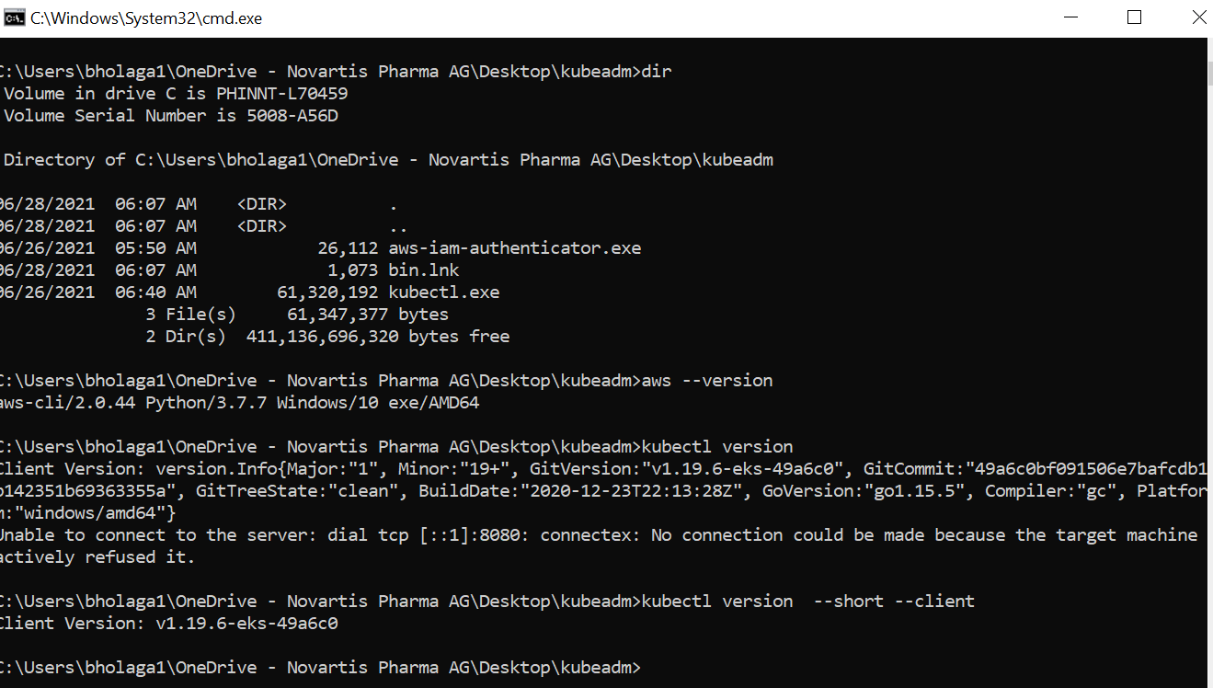

aws eks --region ap-south-1 describe-cluster --name myfirstcluster --query cluster.status

aws eks --region ap-south-1 update-kubeconfig --name myfirstcluster

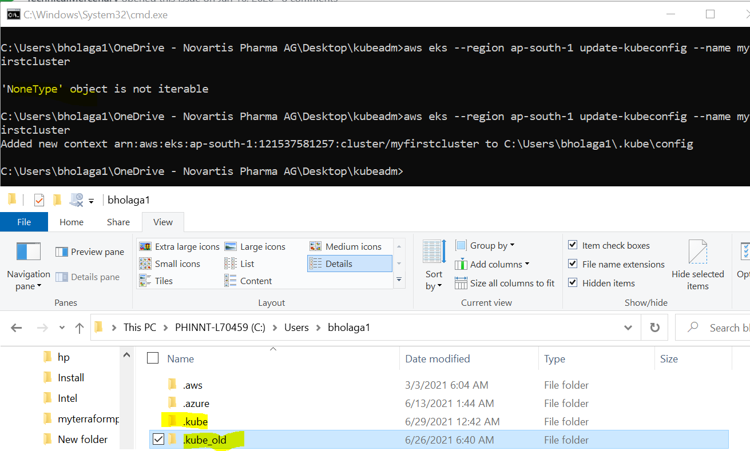



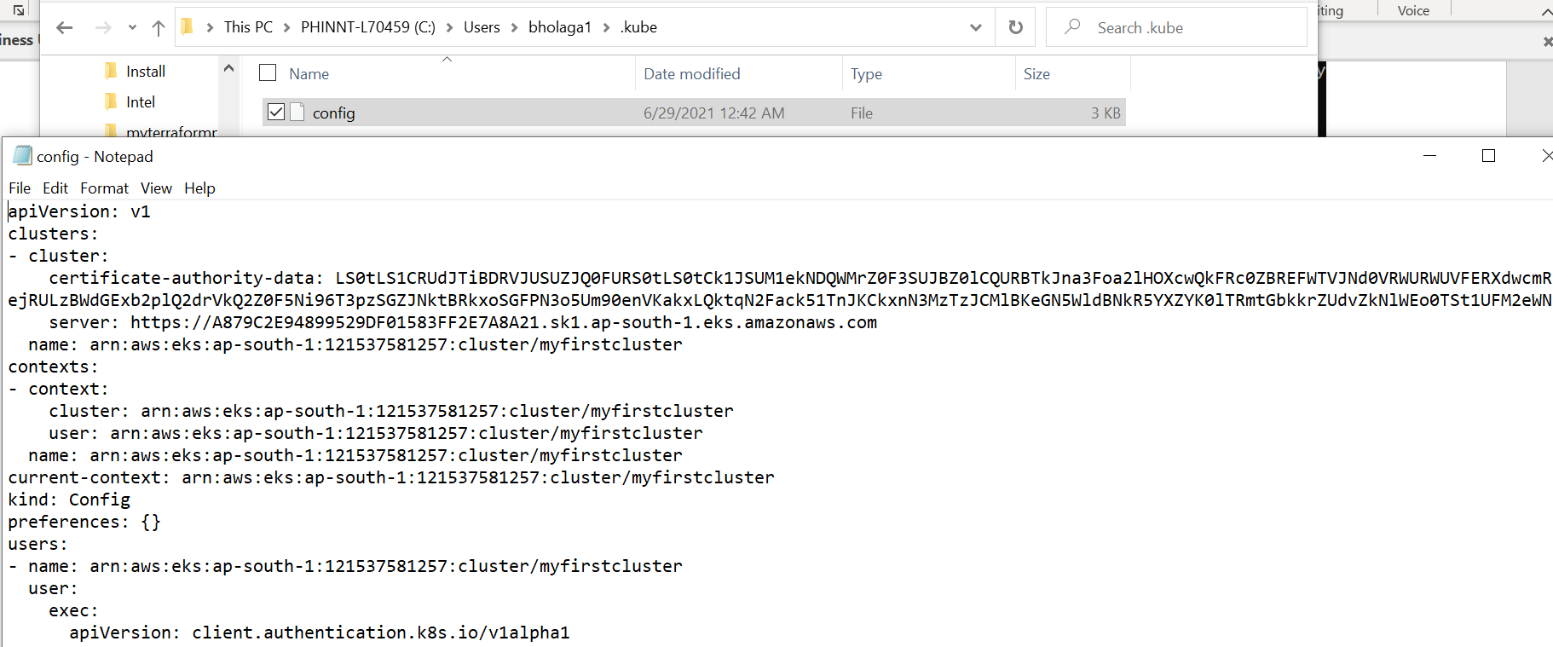

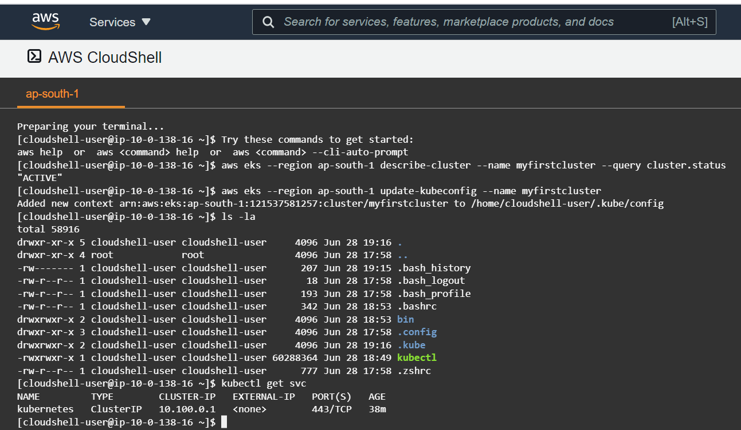

Master IAM role

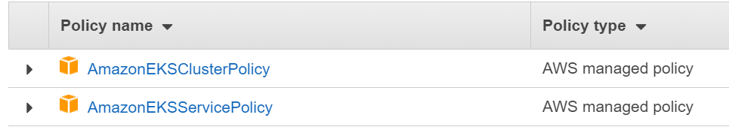

WorkerNode IAM role

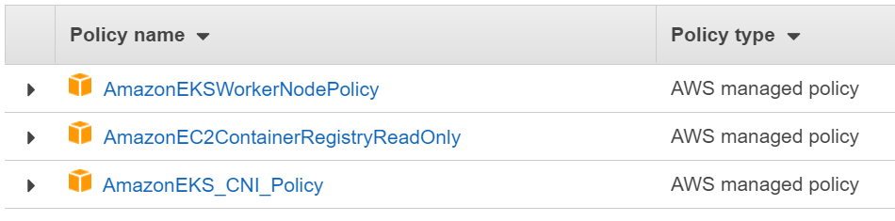

Kubectl get nodes --watch

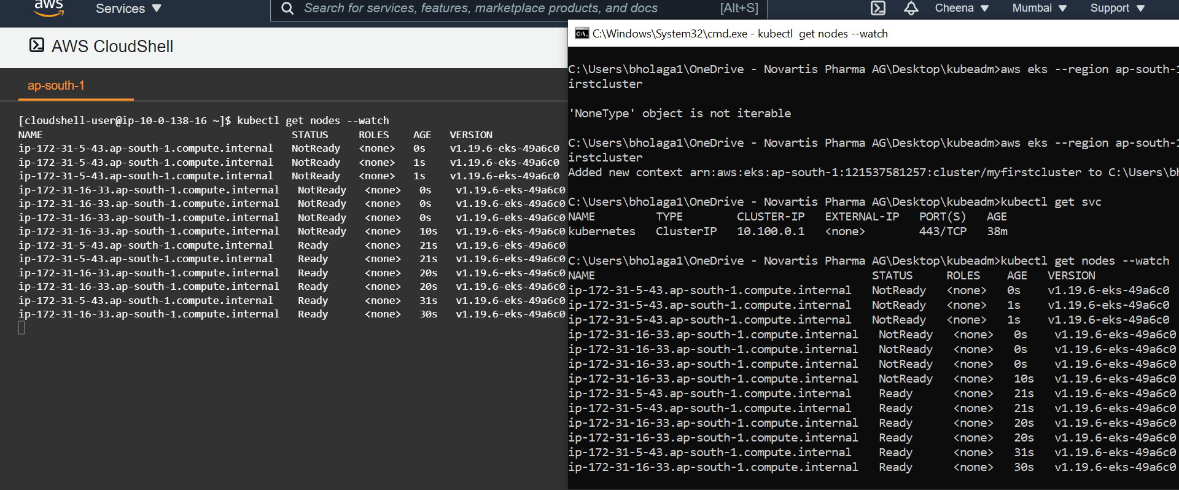

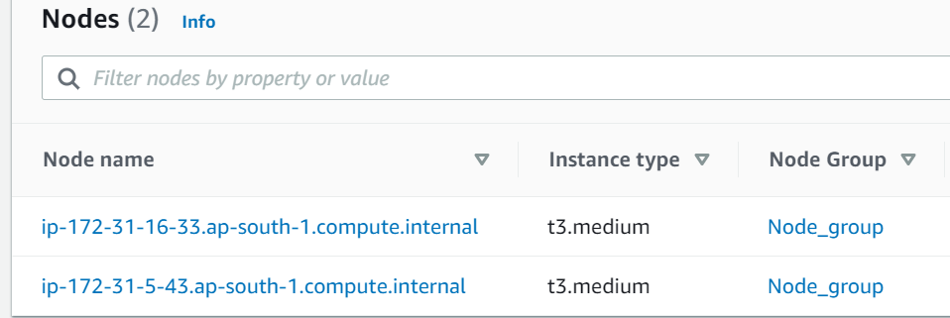

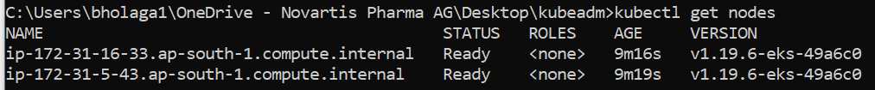



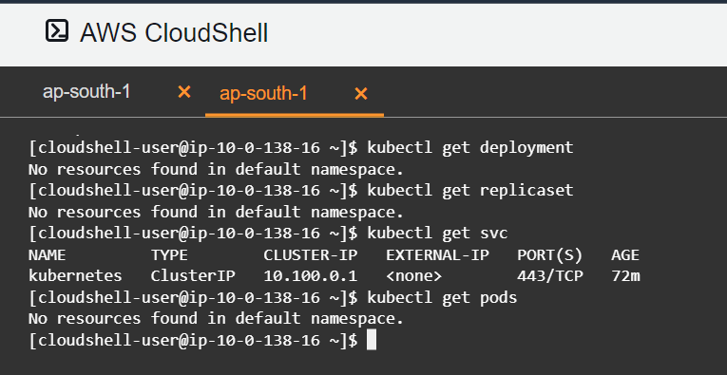

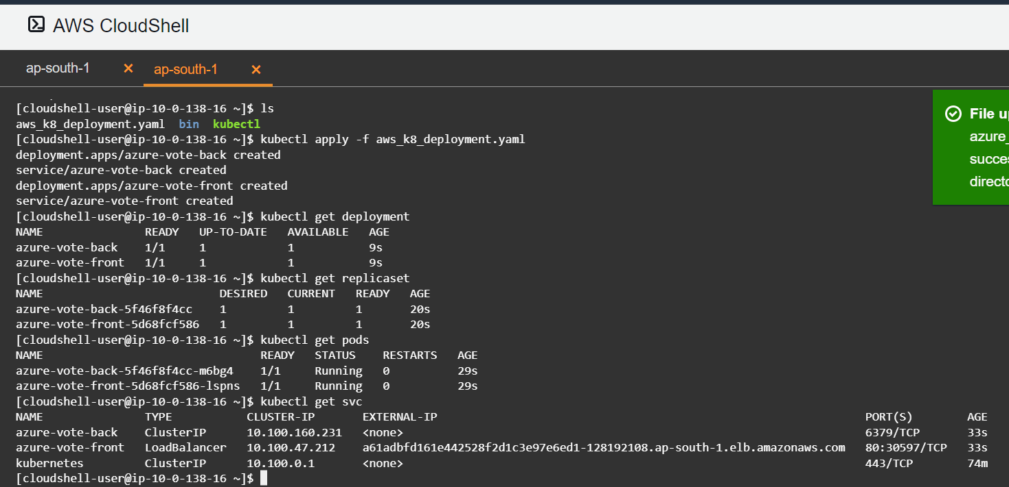

<http://a61adbfd161e442528f2d1c3e97e6ed1-128192108.ap-south-1.elb.amazonaws.com/>

app accessible from outside